CS-114 - Fundamental of Programing

Lab Report # 02

**Course Instructor:** Dr Jawad Khan

# Lab Instructor: Muhammad Affan

**Student Name:** Muhammad Ali Shahzadah (section B)

**CMS ID:** 466353

**DATE:** 10/03/2023

**Lab Manual # 02**

**Objective:**

This assignment is about familiarization with performing some basic mathematical operations using C++.

**Task 1:**

Write a C++ program to calculate distance between two points. The values should of coordinates should be input by user.



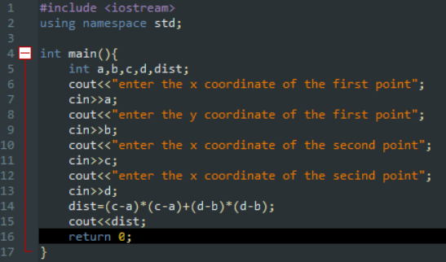

**Task 2:**

Write a code in C++ to take length from user in centimeter and convert it into meter and kilometer.

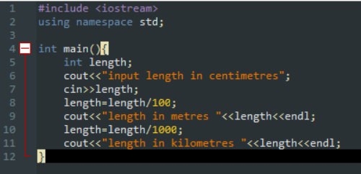

**Task 3:**

Write a code in C++ that takes values of a and b from the user and displays result of polynomial

𝑎*2 + 2*𝑎𝑏 *+* 𝑏*2*.

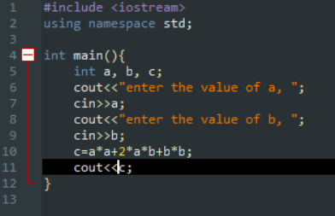

**Task 4:**

Write a program in C++ to convert temperature in Fahrenheit to Celsius.

